NAME: NIVETHITHA R
REG NO:23MIS0657
SUBJECT: USER INTERFACE AND USER EXPERIENCE LAB
FACULTY: KALAIVANI

Bad Design 1: Small Bag Shelf

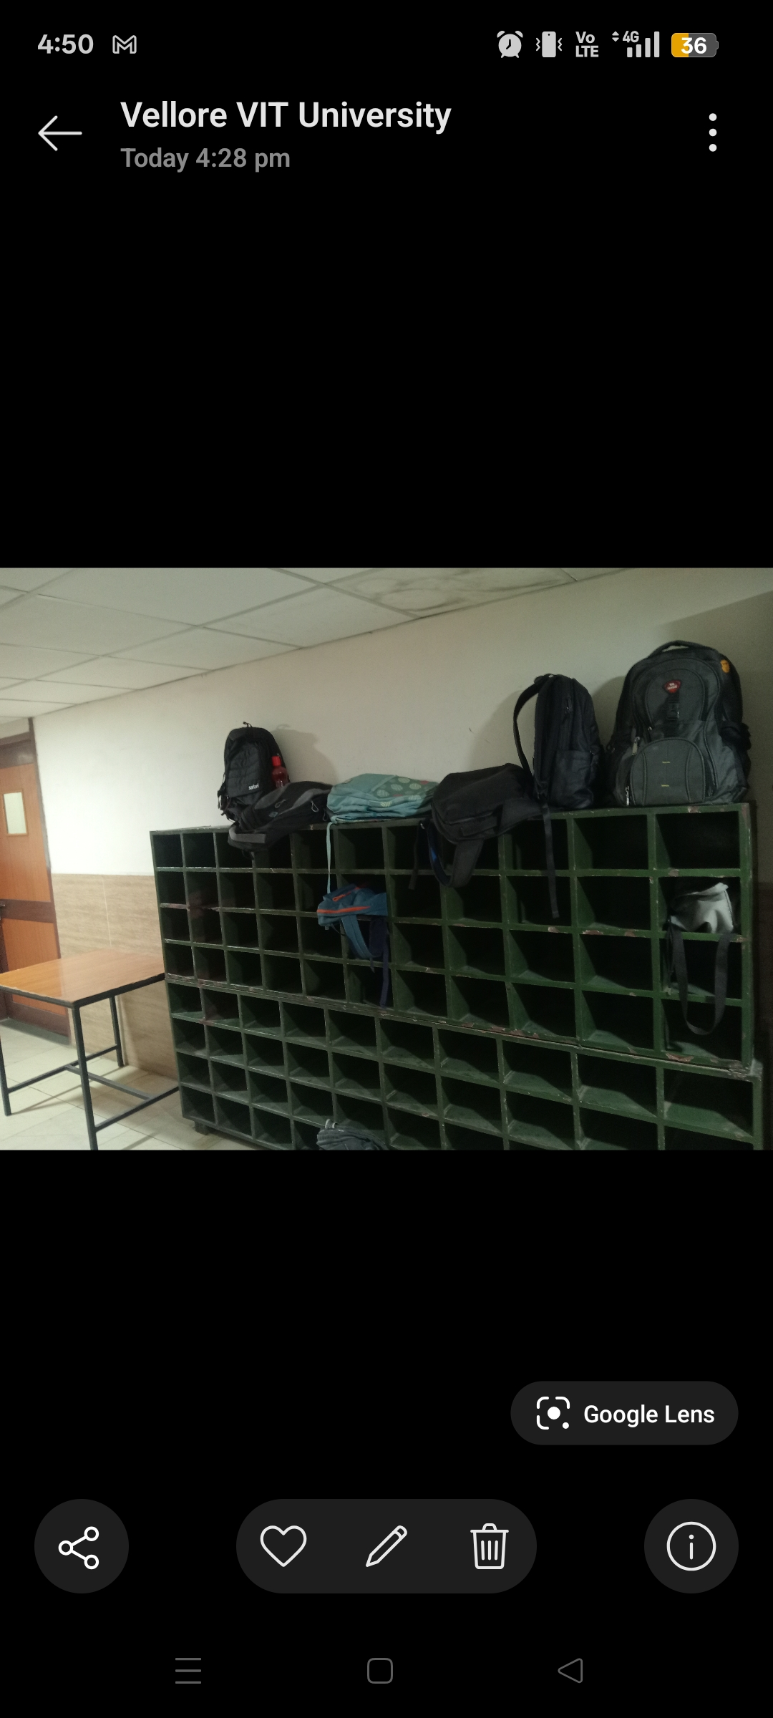

B

Description:

The bag shelf provided in the classroom is too small to accommodate students' backpacks. As a result, most students keep their bags on top of the shelf instead of inside the rack, making the storage area untidy and inconvenient.

Source of Photograph: (GPS-enabled, Captured Picture)

Place: VIT Vellore – Classroom

Reasons why the design is bad:

Shelf size is too small for standard backpacks.

Students cannot store bags inside the rack.

Bags kept on top may fall easily.

The storage area looks untidy.

Reduces convenience for students.

Suggested Improvement:

Increase the shelf dimensions.

Design racks suitable for laptop backpacks.

Add deeper and wider compartments.

Clearly assign storage spaces.

BAD DESIGN 2: Students Sitting in the Pathway
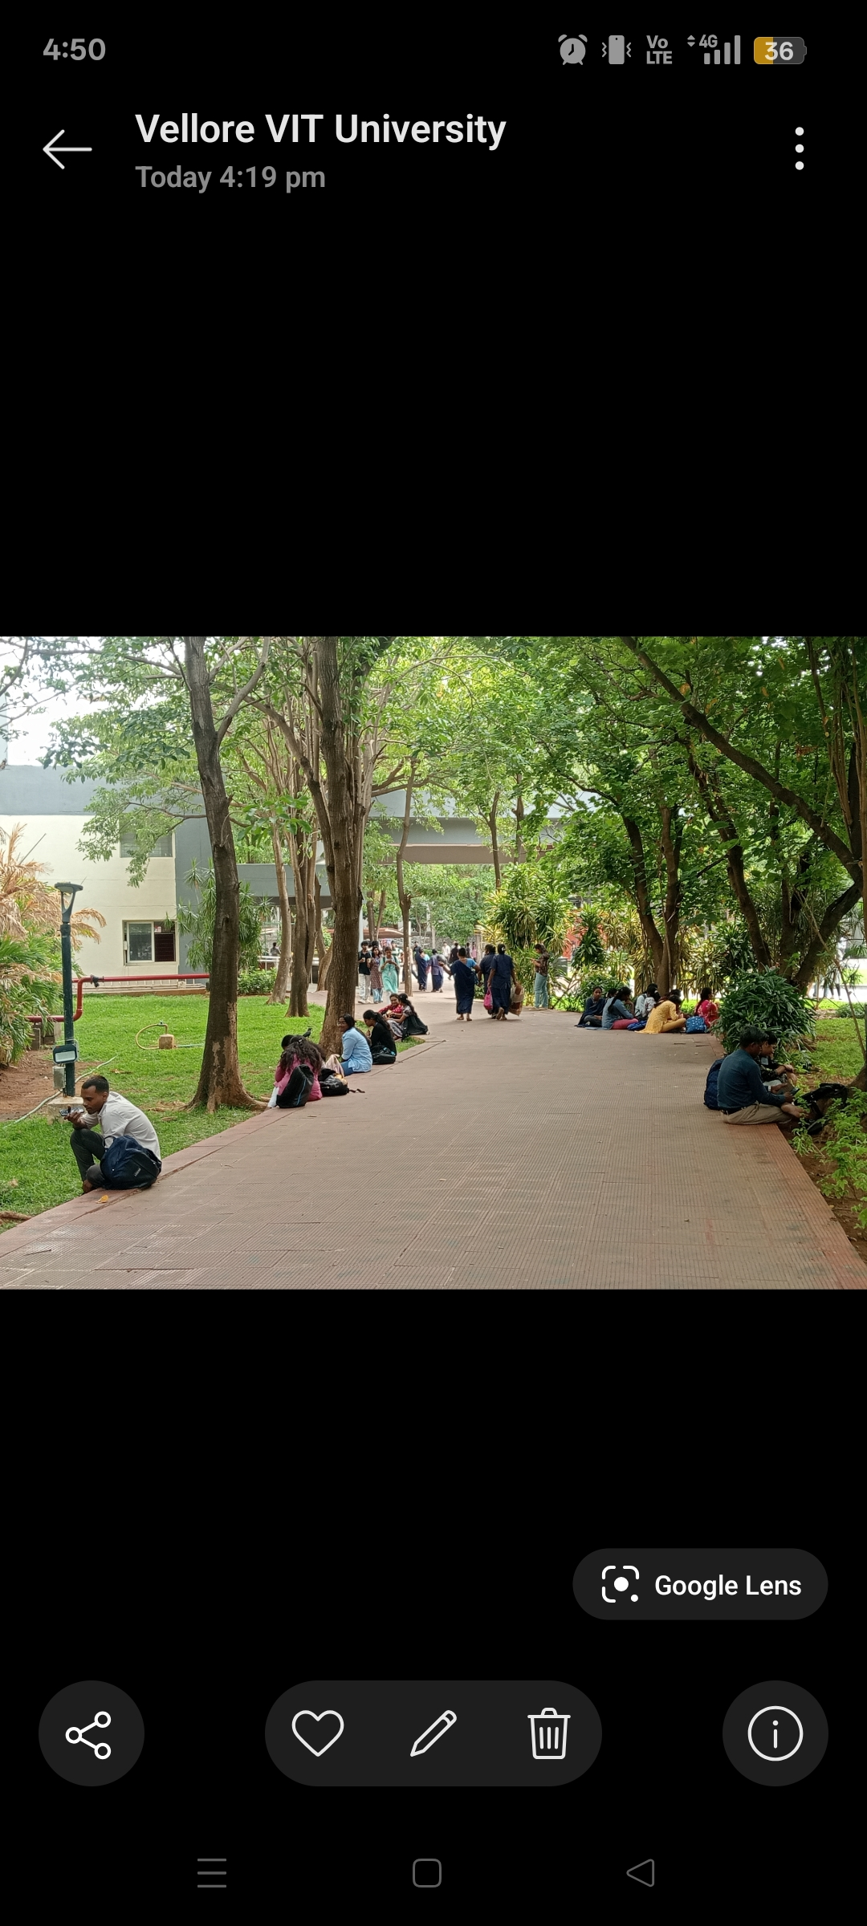

a

Description:

Students often sit in the corridor or pathway during free hours because they are unable to identify vacant classrooms. This blocks the pathway and creates an unorganized environment.

Source of Photograph: (GPS-enabled, Captured Picture)

Place: VIT Vellore – Academic Block Corridor

Reasons why the design is bad:

Pathways become crowded.

Students cannot find available classrooms.

Sitting on the floor is uncomfortable for long durations.

Obstructs movement of others.

Creates an untidy appearance.

Suggested Improvement:

Display vacant classroom information digitally.

Install information screens.

Provide designated waiting areas.

Improve classroom occupancy management.

BAD DESIGN 3:No Building Map at SJT Entrance

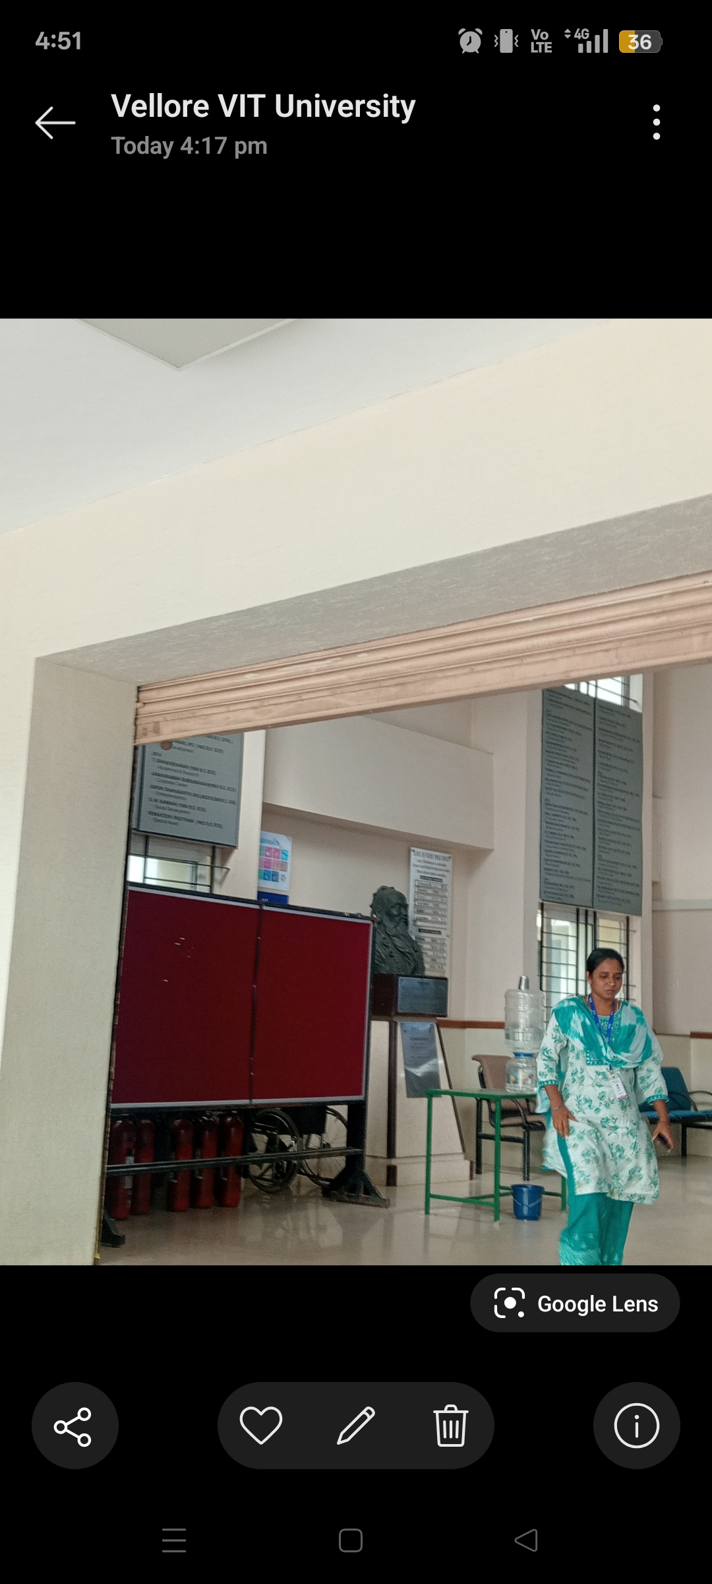

Description:

The entrance of the SJT building does not have a building map or directory. Freshers and visitors often struggle to locate classrooms, laboratories, or offices.

Source of Photograph: (GPS-enabled, Captured Picture)

Place: VIT Vellore – SJT Entrance

Reasons why the design is bad:

No navigation guidance.

Freshers find it difficult to locate rooms.

Wastes time searching.

Causes confusion among visitors.

Poor first-time user experience.

Suggested Improvement:

Install a large building map at the entrance.

Add floor-wise directories.

Include QR codes for digital navigation.

Place directional signboards throughout the building.

BAD DESIGN 4: Unlabelled Dustbin

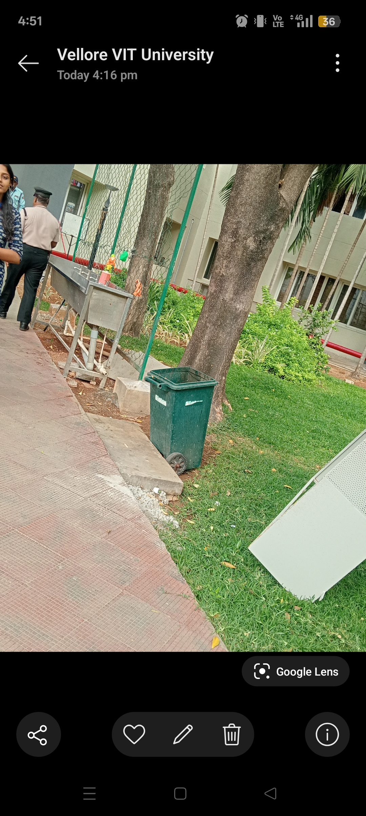

Description:

The dustbin placed on campus does not have any label indicating its purpose. It is also placed irregularly, making it difficult for students to locate and use properly.

Source of Photograph: (GPS-enabled, Captured Picture)

Place: VIT Vellore – Campus

Reasons why the design is bad:

No identification label.

Difficult to locate.

Irregular placement.

Encourages improper waste disposal.

Reduces campus cleanliness.

Suggested Improvement:

Add clear "Dustbin" labels.

Place bins at regular intervals.

Use color-coded bins for waste segregation.

Install directional signs if needed.

BAD DESIGN 5:Unorganized Pen Display in Shop

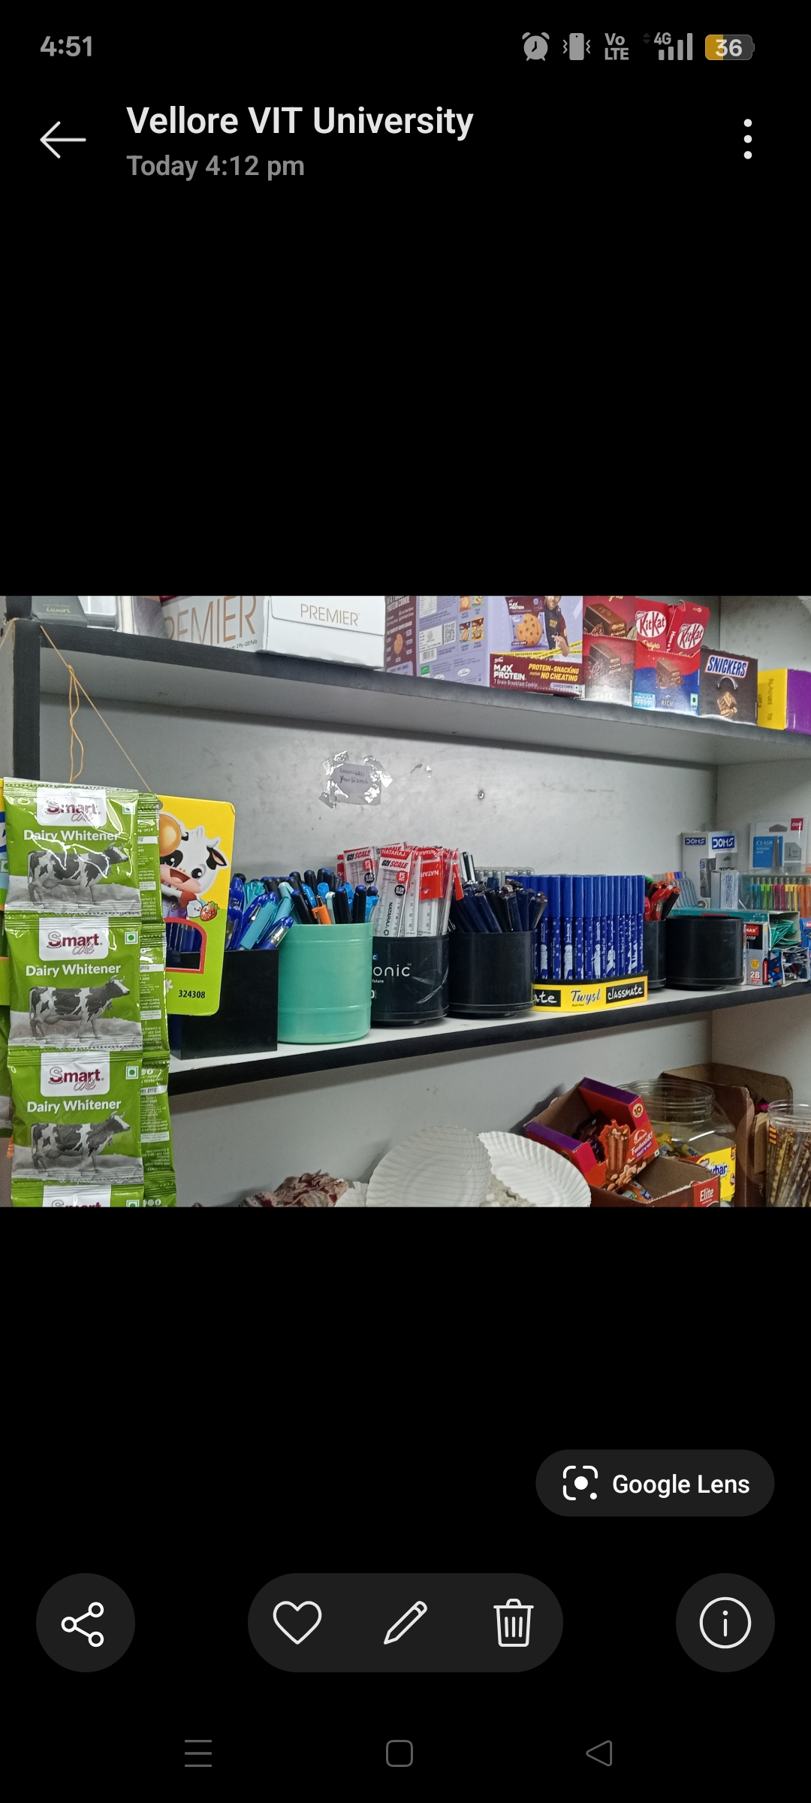

Description:

The shop displays all pens together without separating gel pens, ballpoint pens, or marker pens. Customers find it difficult to identify the required pen.

Source of Photograph: (GPS-enabled, Captured Picture)

Place: Stationery Shop – VIT Campus

Reasons why the design is bad:

Pens are mixed together.

Difficult to identify pen types.

Increases selection time.

Customers may purchase the wrong product.

Poor product organization.

Suggested Improvement:

Separate pens by category.

Add clear labels for each section.

Use color-coded shelves.

Arrange products neatly.

